|  |
| --- |
| Student:_____________________ Date Completed:________________ |
| **Private and Commercial Pilot Flight Training** |
| **Normal and Crosswind Takeoffs** |
| Objective: |
| To develop the student's skill and knowledge of the normal and crosswind takeoffs. |

|  |
| --- |
| Elements: |
| 1. Review of wind conditions. 2. Takeoff hazards including wind shear and wake turbulence. 3. Use of wing flaps. 4. Alignment with takeoff path. 5. Initial positioning of flight controls. 6. Power application. 7. Directional control during acceleration on the surface. 8. Crosswind control technique during acceleration on the surface, lift-off attitude and airspeed. 9. Climb attitude, power setting, and airspeed (Vy or Vx). 10. Crosswind correction and track during climb. 11. Use of checklist. |

|  |  |
| --- | --- |
| Schedule: | |
| Preflight Discussion | 0:15 |
| Inflight Demonstration and Student Practice | 0:30 |
| Postflight Discussion | 0:15 |
| All Times Dependent on Pilot's Ability | |

|  |  |
| --- | --- |
| Equipment: | |
| Aircraft | Drawing Surface and Marking Utensil |

|  |  |
| --- | --- |
| Instructor's Actions: | Student's Actions: |
| **PREFLIGHT:**   * Discuss lesson objective * Discuss common student errors in performing the maneuver. * Discuss the FAA's emphasis on safety including collision avoidance and division of attention.   **INFLIGHT:**   * Demonstrate the maneuver. * Coach student practice. * Evaluate student understanding of maneuver.   **POSTFLIGHT:**   * Critique student performance. * Answer student questions. * Assign homework for next lesson. | **PREFLIGHT:**   * Discuss lesson objective. * Listens and takes notes. * Resolves Questions.   I**NFLIGHT:**   * Reviews maneuvers. * Pays attention and asks questions. * Practices maneuver as directed. * Answers questions posed by instructor.   **POSTFLIGHT:**   * Ask pertinent questions. * Answers questions posed by instructor. * Critiques own performance. * Completes assigned homework. |

|  |
| --- |
| Private and Commercial Pilot Flight Training |
| Private Pilot Completion Standards: FAA-H-8081-14AS (Private PTS, IV., A., 1-10) |
| 1. Exhibits knowledge of the elements related to a normal and crosswind takeoff, climb operations, and rejected takeoff procedures. |
| 1. Positions the flight controls for the existing wind conditions. |
| 1. Clears the area; taxies into the takeoff position and aligns the airplane on the runway center/takeoff path. |
| 1. Lifts off at the recommended airspeed and accelerates to VY. |
| 1. Establishes a pitch attitude that will maintain VY +10/-5 knots. |
| 1. Retracts the landing gear, if appropriate, and flaps after a positive rate of climb is established. |
| 1. Maintains takeoff power and VY +10/-5 knots to a safe maneuvering altitude. |
| 1. Maintains directional control and proper wind-drift correction throughout the takeoff and climb. |
| 1. Complies with noise abatement procedures. |
| 1. Completes the appropriate checklist. |
| Commercial Pilot Completion Standards: FAA-H-8081-12B (Commercial PTS, IV., A., 1-10) |
| 1. Exhibits knowledge of the elements related to a normal and crosswind takeoff, climb operations, and rejected takeoff procedures. |
| 1. Positions the flight controls for the existing wind conditions. |
| 1. Clears the area; taxies into the takeoff position and aligns the airplane on the runway center/takeoff path. |
| 1. Lifts off at the recommended airspeed and accelerates to VY. |
| 1. Establishes a pitch attitude that will maintain VY +/-5 knots. |
| 1. Retracts the landing gear, if appropriate, and flaps after a positive rate of climb is established. |
| 1. Maintains takeoff power and VY +/-5 knots to a safe maneuvering altitude. |
| 1. Maintains directional control and proper wind-drift correction throughout the takeoff and climb. |
| 1. Complies with noise abatement procedures. |
| 1. Completes the appropriate checklist. |

|  |
| --- |
| Common Errors: FAA-H-8083-3A (Chapter 5-2) |
| 1. Failure to adequately clear the area prior to taxiing in to position on the active runway. 2. Abrupt use of the throttle. 3. Failure to check engine instruments for signs of malfunction after applying takeoff power. 4. Failure to anticipate the airplane’s left turning tendency on initial acceleration. 5. Overcorrecting for left turning tendency. 6. Relying solely on the airspeed indicator rather than developed feel for indications during lift off. 7. Failure to attain proper lift-off attitude. 8. Inadequate compensation for toque / P-factor during initial climb resulting in a sideslip. 9. Over-control of elevators during initial climb out. 10. Limiting scan to directly ahead of the airplane, resulting in allowing a wing (usually the left) to drop immediately after lift-off. 11. Failure to attain / maintain best rate-of-climb airspeed (Vy). 12. Failure to employ attitude flying during climb-out, resulting in “chasing” the airspeed indicator. |

|  |  |
| --- | --- |
| Private and Commercial Pilot Flight Training | |
| References: | |
| FAA-H-8083-3A (Chapter 5-2) | FAA-H-8081-14AS (Private PTS, IV., A., 1-10) |
| POH / AFM | FAA-H-8081-12B (Commercial PTS, IV., A., 1-10) |

|  |
| --- |
| Things to Remember: |
| Hand on throttle unless trimming until safe altitude. |

Instructor notes and visual aids

|  |
| --- |
| Private & Commercial Pilot Flight Training |
| Performing Normal Takeoffs: |
| **NORMAL TAKEOFF**   * A normal takeoff is one in which the airplane is headed into the wind, or the wind is very light. * Also, the takeoff surface is firm and of sufficient length to permit the airplane to gradually accelerate to normal lift-off and climb-out speed, and there are no obstructions along the takeoff path. * There are two reasons for making a takeoff as nearly into the wind as possible. * First, the airplane’s speed while on the ground is much less than if the takeoff were made downwind, thus reducing wear and stress on the landing gear. * Second, a shorter ground roll and therefore much less runway length is required to develop the minimum lift necessary for takeoff and climb. * Since the airplane depends on airspeed in order to fly, a headwind provides some of that airspeed, even with the airplane motionless, from the wind flowing over the wings.   **TAKEOFF ROLL**   * After taxiing onto the runway, the airplane should be carefully aligned with the intended takeoff direction, and the nose wheel positioned straight, or centered. * After releasing the brakes, the throttle should be advanced smoothly and continuously to takeoff power. * An abrupt application of power may cause the airplane to yaw sharply to the left because of the torque effects of the engine and propeller. As the airplane starts to roll forward, the pilot should assure both feet are on the rudder pedals so that the toes or balls of the feet are on the rudder portions, not on the brake portions. * Engine instruments should be monitored during the takeoff roll for any malfunctions. * In nose wheel-type airplanes, pressures on the elevator control are only necessary to steady it. * Applying unnecessary pressure will only aggravate the takeoff and prevent the pilot from recognizing when elevator control pressure is actually needed to establish the takeoff attitude. * As speed is gained, the elevator control will tend to assume a neutral position if the airplane is correctly trimmed. * At the same time, directional control should be maintained with smooth, prompt, positive rudder corrections throughout the takeoff roll. * The effects of engine torque and P-factor at the initial speeds tend to pull the nose to the left. * The pilot must use whatever rudder pressure and aileron needed to correct for these effects or for existing wind conditions to keep the nose of the airplane headed straight down the runway. * The use of brakes for steering purposes should be avoided, since this will cause slower acceleration of the airplane’s speed, lengthen the takeoff distance, and possibly result in severe swerving. * While the speed of the takeoff roll increases, more and more pressure will be felt on the flight controls, particularly the elevators and rudder. * If the tail surfaces are affected by the propeller slipstream, they become effective first. * As the speed continues to increase, all of the flight controls will gradually become effective enough to maneuver the airplane about its three axes. * It is at this point, in the taxi to flight transition, that the airplane is being flown more than taxied. * As this occurs, progressively smaller rudder deflections are needed to maintain direction. * The feel of resistance to the movement of the controls and the airplane’s reaction to such movements are the only real indicators of the degree of control attained. * This feel of resistance is not a measure of the airplane’s speed, but rather of its controllability. * To determine the degree of controllability, the pilot must be conscious of the reaction of the airplane to the control pressures and immediately adjust the pressures as needed to control the airplane. * The pilot must wait for the reaction of the airplane to the applied control pressures and attempt to sense the control resistance to pressure rather than attempt to control the airplane by movement of the controls. * Balanced control surfaces increase the importance of this point, because they materially reduce the intensity of the resistance offered to pressures exerted by the pilot. * At this stage of training, beginning takeoff practice, a student pilot will normally not have a full appreciation of the variations of control pressures with the speed of the airplane. * The student, therefore, may tend to move the controls through wide ranges seeking the pressures that are familiar and expected, and as a consequence over-control the airplane. * The situation may be aggravated by the sluggish reaction of the airplane to these movements. * The flight instructor should take measures to check these tendencies and stress the importance of the development of feel. * The student pilot should be required to feel lightly for resistance and accomplish the desired results by applying pressure against it. * This practice will enable the student pilot, as experience is gained, to achieve a sense of the point when sufficient speed has been acquired for the takeoff, instead of merely guessing, fixating on the airspeed indicator, or trying to force performance from the airplane.   **LIFT-OFF**   * Since a good takeoff depends on the proper takeoff attitude, it is important to know how this attitude appears and how it is attained. * The ideal takeoff attitude requires only minimum pitch adjustments shortly after the airplane lifts off to attain the speed for the best rate of climb (VY). * The pitch attitude necessary for the airplane to accelerate to VY speed should be demonstrated by the instructor and memorized by the student. * Initially, the student pilot may have a tendency to hold excessive back-elevator pressure just after lift-off, resulting in an abrupt pitch-up. * The flight instructor should be prepared for this. * Each type of airplane has a best pitch attitude for normal lift-off; however, varying conditions may make a difference in the required takeoff technique. * A rough field, a smooth field, a hard surface runway, or a short or soft, muddy field, all call for a slightly different technique, as will smooth air in contrast to a strong, gusty wind. * The different techniques for those other-than-normal conditions are discussed later in this chapter. * When all the flight controls become effective during the takeoff roll in a nose wheel-type airplane, back elevator pressure should be gradually applied to raise the nose wheel slightly off the runway, thus establishing the takeoff or lift-off attitude. * This is often referred to as “rotating.” * At this point, the position of the nose in relation to the horizon should be noted, then back-elevator pressure applied as necessary to hold this attitude. * The wings must be kept level by applying aileron pressure as necessary. * The airplane is allowed to fly off the ground while in the normal takeoff attitude. * Forcing it into the air by applying excessive back-elevator pressure would only result in an excessively high pitch attitude and may delay the takeoff. * As discussed earlier, excessive and rapid changes in pitch attitude result in proportionate changes in the effects of torque, thus making the airplane more difficult to control. * Although the airplane can be forced into the air, this is considered an unsafe practice and should be avoided under normal circumstances. * If the airplane is forced to leave the ground by using too much back-elevator pressure before adequate flying speed is attained, the wing’s angle of attack may be excessive, causing the airplane to settle back to the runway or even to stall. * On the other hand, if sufficient back-elevator pressure is not held to maintain the correct takeoff attitude after becoming airborne, or the nose is allowed to lower excessively, the airplane may also settle back to the runway. This would occur because the angle of attack is decreased and lift diminished to the degree where it will not support the airplane. * It is important, then, to hold the correct attitude constant after rotation or liftoff. * Outside visual scan to attain/maintain proper airplane pitch and bank attitude is intensified at this point. * The flight controls have not yet become fully effective, and the beginning pilot will often have a tendency to fixate on the airplane’s pitch attitude and/or the airspeed indicator and neglect the natural tendency of the airplane to roll just after breaking ground. * During takeoffs in a strong, gusty wind, it is advisable that an extra margin of speed be obtained before the airplane is allowed to leave the ground. * A takeoff at the normal takeoff speed may result in a lack of positive control, or a stall, when the airplane encounters a sudden lull in strong, gusty wind, or other turbulent air currents. * In this case, the pilot should allow the airplane to stay on the ground longer to attain more speed; then make a smooth, positive rotation to leave the ground.   **INITIAL CLIMB**   * Upon lift-off, the airplane should be flying at approximately the pitch attitude that will allow it to accelerate * to VY. * This is the speed at which the airplane will gain the most altitude in the shortest period of time. * If the airplane has been properly trimmed, some back elevator pressure may be required to hold this attitude * until the proper climb speed is established. * On the other hand, relaxation of any back-elevator pressure before this time may result in the airplane settling, even to the extent that it contacts the runway. * The airplane will pick up speed rapidly after it becomes airborne. * Once a positive rate of climb is established, the flaps and landing gear can be retracted (if equipped). * It is recommended that takeoff power be maintained until reaching an altitude of at least 500 feet above the surrounding terrain or obstacles. * The combination of VY and takeoff power assures the maximum altitude gained in a minimum amount of time. This gives the pilot more altitude from which the airplane can be safely maneuvered in case of an engine failure or other emergency. * Since the power on the initial climb is fixed at the takeoff power setting, the airspeed must be controlled by making slight pitch adjustments using the elevators. * However, the pilot should not fixate on the airspeed indicator when making these pitch changes, but should, instead, continue to scan outside to adjust the airplane’s attitude in relation to the horizon. * In accordance with the principles of attitude flying, the pilot should first make the necessary pitch change with reference to the natural horizon and hold the new attitude momentarily, and then glance at the airspeed indicator as a check to see if the new attitude is correct. * Due to inertia, the airplane will not accelerate or decelerate immediately as the pitch is changed. * It takes a little time for the airspeed to change. * If the pitch attitude has been over or under corrected, the airspeed indicator will show a speed that is more or less than that desired. * When this occurs, the cross-checking and appropriate pitch-changing process must be repeated until the desired climbing attitude is established. * When the correct pitch attitude has been attained, it should be held constant while cross-checking it against the horizon and other outside visual references. * The airspeed indicator should be used only as a check to determine if the attitude is correct. * After the recommended climb airspeed has been established, and a safe maneuvering altitude has been reached, the power should be adjusted to the recommended climb setting and the airplane trimmed to relieve the control pressures. * This will make it easier to hold a constant attitude and airspeed. * During initial climb, it is important that the takeoff path remain aligned with the runway to avoid drifting into obstructions, or the path of another aircraft that may be taking off from a parallel runway. * Proper scanning techniques are essential to a safe takeoff and climb, not only for maintaining attitude and direction, but also for collision avoidance in the airport area. * When the student pilot nears the solo stage of flight training, it should be explained that the airplane’s takeoff performance will be much different when the instructor is out of the airplane. * Due to decreased load, the airplane will become airborne sooner and will climb more rapidly. * The pitch attitude that the student has learned to associate with initial climb may also differ due to decreased weight, and the flight controls may seem more sensitive. * If the situation is unexpected, it may result in increased tension that may remain until after the landing. Frequently, the existence of this tension and the uncertainty that develops due to the perception of an “abnormal” takeoff results in poor performance on the subsequent landing. |

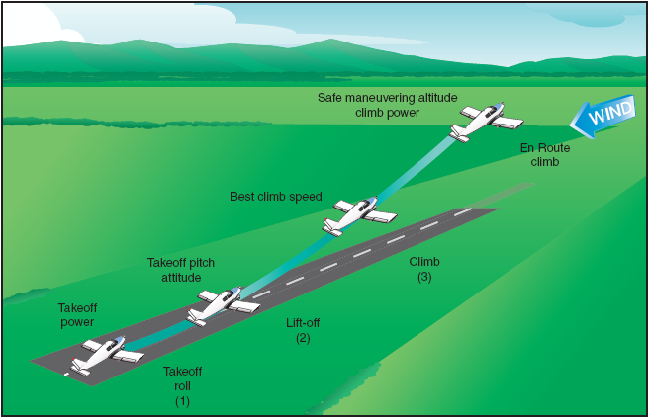

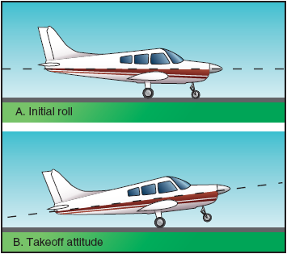

|  |
| --- |
| Private & Commercial Pilot Flight Training |
| Performing Crosswind Takeoffs: |
| **CROSSWIND TAKEOFF**   * While it is usually preferable to take off directly into the wind whenever possible or practical, there will be many instances when circumstances or judgment will indicate otherwise. * Therefore, the pilot must be familiar with the principles and techniques involved in crosswind takeoffs, as well as those for normal takeoffs. * A crosswind will affect the airplane during takeoff much as it does in taxiing. * With this in mind, it can be seen that the technique for crosswind correction during takeoffs closely parallels the crosswind correction techniques used in taxiing.   **TAKEOFF ROLL**   * The technique used during the initial takeoff roll in a crosswind is generally the same as used in a normal * takeoff, except that aileron control must be held INTO the crosswind. * This raises the aileron on the upwind wing to impose a downward force on the wing to counteract the lifting force of the crosswind and prevents the wing from rising. * As the airplane is taxied into takeoff position, it is essential that the windsock and other wind direction indicators be checked so that the presence of a crosswind may be recognized and anticipated. * If a crosswind is indicated, FULL aileron should be held into the wind as the takeoff roll is started. * This control position should be maintained while the airplane is accelerating and until the ailerons start becoming sufficiently effective for maneuvering the airplane about its longitudinal axis. * With the aileron held into the wind, the takeoff path must be held straight with the rudder. * Normally, this will require applying downwind rudder pressure, since on the ground the airplane will tend to **weathervane** into the wind. * When takeoff power is applied, torque or P-factor that yaws the airplane to the left may be sufficient to counteract the weathervaning tendency caused by a crosswind from the right. * On the other hand, it may also aggravate the tendency to swerve left when the wind is from the left. * In any case, whatever rudder pressure is required to keep the airplane rolling straight down the runway should be applied. * As the forward speed of the airplane increases and the crosswind becomes more of a relative headwind, the mechanical holding of full aileron into the wind should be reduced. * It is when increasing pressure is being felt on the aileron control that the ailerons are becoming more effective. As the aileron’s effectiveness increases and the **crosswind component** of the relative wind becomes less effective, it will be necessary to gradually reduce the aileron pressure. * The crosswind component effect does not completely vanish, so some aileron pressure will have to be maintained throughout the takeoff roll to keep the crosswind from raising the upwind wing. * If the upwind wing rises, thus exposing more surface to the crosswind, a “skipping” action may result. * This is usually indicated by a series of very small bounces, caused by the airplane attempting to fly and then settling back onto the runway. * During these bounces, the crosswind also tends to move the airplane sideways, and these bounces will develop into side-skipping. * This side-skipping imposes severe side stresses on the landing gear and could result in structural failure. * It is important, during a crosswind takeoff roll, to hold sufficient aileron into the wind not only to keep the upwind wing from rising but to hold that wing down so that the airplane will, immediately after lift-off, be * **side slipping** into the wind enough to counteract drift.   **LIFT-OFF**   * As the nose wheel is being raised off the runway, the holding of aileron control into the wind may result in * the downwind wing rising and the downwind main wheel lifting off the runway first, with the remainder * of the takeoff roll being made on that one main wheel. * This is acceptable and is preferable to side-skipping. * If a significant crosswind exists, the main wheels should be held on the ground slightly longer than in a normal takeoff so that a smooth but very definite liftoff can be made. * This procedure will allow the airplane to leave the ground under more positive control so that it will definitely remain airborne while the proper amount of wind correction is being established. * More importantly, this procedure will avoid imposing excessive side-loads on the landing gear and prevent possible damage that would result from the airplane settling back to the runway while drifting. * As both main wheels leave the runway and ground friction no longer resists drifting, the airplane will be slowly carried sideways with the wind unless adequate drift correction is maintained by the pilot. * Therefore, it is important to establish and maintain the proper amount of crosswind correction prior to lift-off by applying aileron pressure toward the wind to keep the upwind wing from rising and applying rudder pressure as needed to prevent weathervaning.   **INITIAL CLIMB**   * If proper crosswind correction is being applied, as soon as the airplane is airborne, it will be side slipping into the wind sufficiently to counteract the drifting effect of the wind. * This side slipping should be continued until the airplane has a positive rate of climb. * At that time, the airplane should be turned into the wind to establish just enough wind correction angle to counteract the wind and then the wings rolled level. * Firm and aggressive use of the rudders will be required to keep the airplane headed straight down the runway. The climb with a wind correction angle should be continued to follow a ground track aligned with the runway direction. * However, because the force of a crosswind may vary markedly within a few hundred feet of the ground, frequent checks of actual ground track should be made, and the wind correction adjusted as necessary. * The remainder of the climb technique is the same used for normal takeoffs and climbs. |

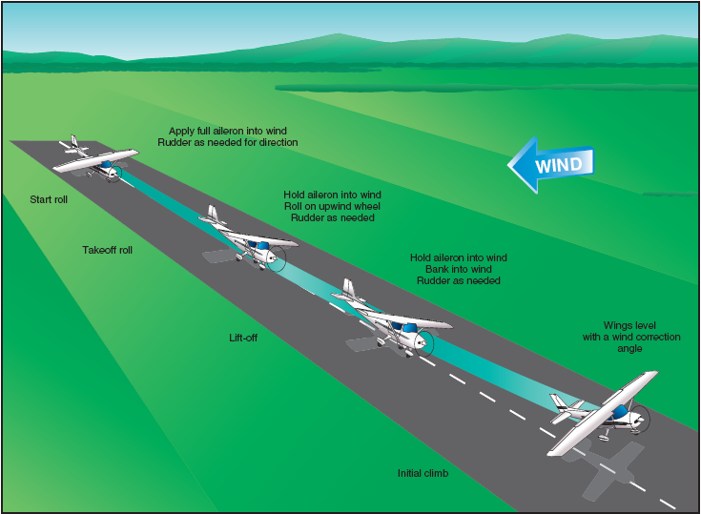

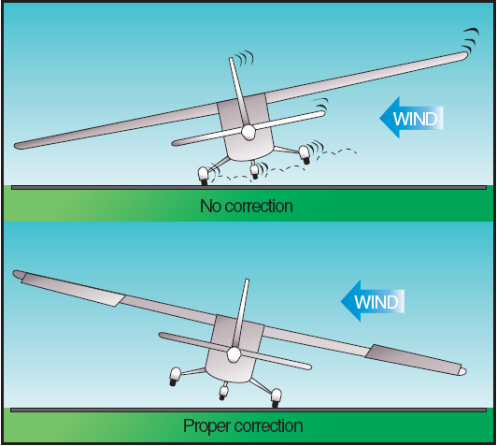

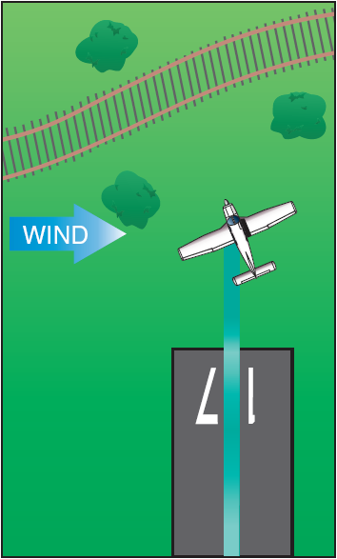

|  |
| --- |
| Private & Commercial Pilot Flight Training |
| Performing Normal Takeoffs: |
| **DESCRIPTION:**   1. Ensure that the Before Takeoff Checklist has been completed.  * Ensure that the items on the Line-up checklist have been completed and / or reviewed. * Visually check for traffic on Downwind, Base, and final in the active and other traffic patterns.  1. Communicate, as appropriate – non-towered airport make traffic advisory call, towered airport read back takeoff clearance.  * Taxi onto the runway, as appropriate. * Complete the items from the Line-up Checklist while taxiing. Use the phrase “lights, camera, action” to help remember any items deferred (lights = lights as appropriate, camera = transponder on / altitude, action = mixture rich). * Taxi the aircraft into position, centered on the runway with the nose wheel straight, as close to the approach end as possible.  1. Smoothly and positively apply full power with heals on the floor so as not to hold brakes. Keep a hand on the throttle in the event an abort becomes necessary.  * Check engine instruments (engine RPM and all other “engine instruments in the green”) and airspeed indicator )”airspeed alive”).  1. At Vr establish and maintain pitch attitude for takeoff. Allow airplane to lift-off when it is ready) approximately Vlof). 2. Establish the pitch attitude enabling climb out at Vy. Maintain a ground track along the runway and extended centerline with coordinated use of rudder and aileron.  * With retractable landing gear, ensure a positive rate of climb, tap the brakes and retract the gear when insufficient runway remains to land the airplane. * Establish cruise climb above a minimum safe altitude (500-1000 AGL). * Note: You should compute takeoff and landing performance data prior to all flights. * Special emphasis should be place on determining that adequate runway exists. |



|  |
| --- |
| Private & Commercial Pilot Flight Training |
| Performing Crosswind Takeoffs: |
| **DESCRIPTION:**   1. Ensure that the Before Takeoff Checklist has been completed.  * Ensure that the items on the Line-up checklist have been completed and / or reviewed. * Visually check for traffic on Downwind, Base, and final in the active and other traffic patterns.  1. Communicate, as appropriate – non-towered airport make traffic advisory call, towered airport read back takeoff clearance.  * Taxi onto the runway, as appropriate. * Complete the items from the Line-up Checklist while taxiing. Use the phrase “lights, camera, action” to help remember any items deferred (lights = lights as appropriate, camera = transponder on / altitude, action = mixture rich). * Taxi the aircraft into position, centered on the runway with the nose wheel straight, as close to the approach end as possible. * Prior to the start of the takeoff run, the ailerons are fully deflected into the wind and the elevator is in the neutral position.  1. Smoothly and positively apply full power with heals on the floor so as not to hold brakes. Keep a hand on the throttle in the event an abort becomes necessary.  * Check engine instruments (engine RPM and all other “engine instruments in the green”) and airspeed indicator )”airspeed alive”). * As the aircraft accelerates, adjust the ailerons as necessary and maintain runway alignment with the rudder.   **Note**: If a significant or gusty conditions crosswind exist, the aircraft should be held on the ground slightly longer than normal so that a smooth and positive lift-off will occur.   1. At Vr establish and maintain pitch attitude for takeoff. Allow airplane to lift-off when it is ready) approximately Vlof).   **Note**: As the aircraft leave the runway, the holding of ailerons into the wind will result in the downwind wing rising and the downwind main wheel lifting off first.   * Once the aircraft lifts off, establish a Wind Correction Angle (WCA) to maintain the runway centerline with level wings.  1. Establish the pitch attitude enabling climb out at Vy. Maintain a ground track along the runway and extended centerline with coordinated use of rudder and aileron.   **Note**: With retractable landing gear, ensure a positive rate of climb, tap the brakes and retract the gear when insufficient runway remains to land the airplane.   1. Establish cruise climb above a minimum safe altitude (500-1000 AGL).   **Note**: You should compute takeoff and landing performance data prior to all flights.   * Special emphasis should be place on determining that adequate runway exists. |

