|  |
| --- |
| Student:_____________________ Date Completed:________________ |
| **Private & Commercial Pilot Flight Training** |
| **Spin Awareness** |
| Objective: |
| To develop knowledge and recognition of the elements related to spin awareness. |

|  |
| --- |
| Elements: |
| 1. **AERODYNAMICS**  * Why does an aircraft spin, and why is it bad? * Phases   + Stall: pre-spin, uncoordinated stall   + Incipient: first few unbalanced turns   + Developed: balanced forces, though not necessarily auto-rotating   + Recovery: control inputs might take one turn or more to take effect * What is autorotation? * Effects of aileron inputs * Effects of power and flat spins * Unrecoverable spins  1. **CONSIDERATIONS**  * Spin-prone situations   + Base-to-final, slow uncoordinated flight * Configurations which worsen spins   + CG location: forward has easier entry and exit than aft   + Weight: heavy is harder to enter, but harder to exit  1. **AWARENESS**  * Banked, opposite rudder, full aft elevator * Enters developed phase after one to two turns * Orientation by outside references   + Tumbling gyros  1. **RECOGNITION AND RECOVERY**  * Wing drop during a stall indicates stall phase of a spin * Recover by upsetting the aerodynamically balanced or balancing forces  1. Rudder opposite to counter the spin 2. Controls neutral to avoid aggravating the spin, forward pressure to break stall 3. Throttle to idle to avoid entering a flat spin 4. Rudder normal 5. Controls to maintain level flight 6. Throttle as required  * Flat spins require throttle to idle and any forward cg changes possible * The pedal with the most resistance will recover the spin * Avoid over speeding in the recovery dive  1. **AIRCRAFT**  * Spin approval * Aircraft category |

|  |  |
| --- | --- |
| Private & Commercial Pilot Flight Training | |
| Schedule: | |
| Preflight Discussion | 0:15 |
| Inflight Demonstration and Student Practice | 0:30 |
| Postflight Discussion | 0:15 |
| All Times Dependent on Pilot's Ability | |

|  |  |
| --- | --- |
| Equipment: | |
| Aircraft | Drawing Surface and Marking Utensil |

|  |  |
| --- | --- |
| Instructor's Actions: | Student's Actions: |
| **PREFLIGHT:**   * Discuss lesson objective * Discuss common student errors in performing the maneuver. * Discuss the FAA's emphasis on safety including collision avoidance and division of attention.   **INFLIGHT:**   * Demonstrate the maneuver. * Coach student practice. * Evaluate student understanding of maneuver.   **POSTFLIGHT:**   * Critique student performance. * Answer student questions. * Assign homework for next lesson. | **PREFLIGHT**   * Discuss lesson objective. * Listens and takes notes. * Resolves Questions.   **INFLIGHT**   * Reviews maneuvers. * Pays attention and asks questions. * Practices maneuver as directed. * Answers questions posed by instructor.   **POSTFLIGHT**   * Ask pertinent questions. * Answers questions posed by instructor. * Critiques own performance. * Completes assigned homework. |

|  |
| --- |
| Private & Commercial Pilot Flight Training |
| Private Pilot Completion Standards: FAA-H-8081-14AS (Private PTS, VIII. D. 1-3) |
| 1. Aerodynamic factors related to spins. |
| 1. Flight situations where unintentional spins may occur. |
| 1. Procedures for recovery from unintentional spins. |
| Commercial Pilot Completion Standards: FAA-H-8081-12B (Commercial PTS, VIII., D., 1-3) |
| 1. Aerodynamic factors related to spins. |
| 1. Flight situations where unintentional spins may occur. |
| 1. Procedures for recovery from unintentional spins. |

|  |
| --- |
| Common Errors: FAA-H-8083-3A (Chapter 4-16) |
| 1. Failure to apply full rudder pressure in the desired spin direction during spin entry. 2. Failure to apply and maintain full up-elevator pressure during spin entry, resulting in a spiral. 3. Failure to achieve a fully stalled condition prior to spin entry. 4. Failure to apply full rudder against the spin during recovery. 5. Failure to apply sufficient forward-elevator pressure during recovery. 6. Failure to neutralize the rudder during recovery after rotation stops, resulting in a possible secondary spin. 7. Slow and overly cautious control movements during recovery. 8. Excessive back-elevator pressure after rotation stops, resulting in possible secondary stall. 9. Insufficient back-elevator pressure during recovery resulting in excessive airspeed. |

|  |  |
| --- | --- |
| References: | |
| FAA-H-8083-3A (Chapter 4-12 to 4-16) | FAA-S-8081-14AS (Private PTS, VIII. D. 1-3) |
| AC 61-67C | FAA-S-8081-12B (Commercial PTS, VIII. D. 1-3) |

|  |
| --- |
| Things to Remember: |
|  |

|  |
| --- |
| Private & Commercial Pilot Flight Training |
| Spin Procedures: |
| **NOTE:**  Each aircraft that is approved for the demonstration of intentional spin will usually have their own spin entry procedures and recovery procedures. The following procedure is a generic procedure for informational purposes only.  **Spin Entry Procedure:**   1. Clear the area, especially below 2. Reduce speed to Vr and maintain level flight 3. As the stall occurs, pull the control wheel to the full aft position and hold it during the demonstration 4. Apply full rudder in the desired direction of the spin and hold it during the demonstration 5. Allow the airplane to spin to the desired number of turns   **Recovery:**  Use the manufacturers spin recovery procedure. As an emergency use the following:   1. Power to idle 2. Ailerons neutral 3. Rudder full and opposite to the turn until rotation stops 4. Elevator full forward to break the stall 5. When the rotation stops release the rudder and recover from the resulting dive |

**Instructor notes and visual aids**

|  |
| --- |
| Private & Commercial Pilot Flight Training |
| Spin Awareness Narrative: |
| **INTRODUCTION**  A spin may be defined as an aggravated stall that results in what is termed **“autorotation”** wherein the airplane follows a downward corkscrew path.  **MOTIVATION**  During an uncoordinated maneuver, a pilot may not be aware that a critical angle of attack has been exceeded until the airplane yaws out of control toward the lowering wing. If stall recovery is not initiated immediately, the airplane may enter a spin. If this stall occurs while the airplane is in a slipping or skidding turn, this can result in a spin entry and rotation in the direction that the rudder is being applied, regardless of which wingtip is raised. Many airplanes have to be forced to spin and require considerable judgment and technique to get the spin started. These same airplanes that have to be forced to spin, may be accidentally put into a spin by mishandling the controls in turns, stalls, and flight at minimum controllable airspeeds. This fact is additional evidence of the necessity for the practice of stalls until the ability to recognize and recover from them is developed.  Often a wing will drop at the beginning of a stall. When this happens, the nose will attempt to move (yaw) in the direction of the low wing. This is where use of the rudder is important during a stall. The correct amount of opposite rudder must be applied to keep the nose from yawing toward the low wing. By maintaining directional control and not allowing the nose to yaw toward the low wing, before stall recovery is initiated, a spin will be averted. If the nose is allowed to yaw during the stall, the airplane will begin to slip in the direction of the lowered wing, and will enter a spin.  An airplane must be stalled in order to enter a spin; therefore, continued practice in stalls will help the pilot develop a more instinctive and prompt reaction in recognizing an approaching spin. It is essential to learn to apply immediate corrective action any time it is apparent that the airplane is nearing spin conditions. If it is impossible to avoid a spin, the pilot should immediately execute spin recovery procedures.  **DESCRIPTION**  As the airplane rotates around a vertical axis, the rising wing is less stalled than the descending wing creating a rolling, yawing, and pitching motion. The airplane is basically being forced downward by gravity, rolling, yawing, and pitching in a spiral path. The autorotation results from an unequal angle of attack on the airplane’s wings. The rising wing has a decreasing angle of attack, where the relative lift increases and the drag decreases. In effect, this wing is less stalled. Meanwhile, the descending wing has an increasing angle of attack, past the wing’s critical angle of attack (stall) where the relative lift decreases and drag increases. A spin is caused when the airplane’s wing exceeds its critical angle of attack (stall) with a sideslip or yaw acting on the airplane at, or beyond, the actual stall.  **EXECUTING THE MANEUVER**  **SPIN PROCEDURES**  Flight instructor’s should demonstrate spins in those airplanes that are approved for spins. Special spin procedures or techniques required for a particular airplane are not presented here. Before beginning any spin operations, the following items should be reviewed.   * The airplane’s AFM/POH limitations section, placards, or type certification data, to determine if the airplane is approved for spins. * Weight and balance limitations. * Recommended entry and recovery procedures. * The requirements for parachutes. It would be appropriate to review a current Title 14 of the Code of Federal Regulations (14 CFR) part 91 for the latest parachute requirements. * A thorough airplane preflight should be accomplished with special emphasis on excess or loose items that may affect the weight, center of gravity, and controllability of the airplane. * Slack or loose control cables (particularly rudder and elevator) could prevent full anti-spin control deflections and delay or preclude recovery in some airplanes. * Prior to beginning spin training, the flight area, above and below the airplane, must be clear of other air traffic. This may be accomplished while slowing the airplane for the spin entry. * All spin training should be initiated at an altitude high enough for a completed recovery at or above 1,500 feet AGL. * It may be appropriate to introduce spin training by first practicing both power-on and power-off stalls, in a clean configuration. * This practice would be used to familiarize the student with the airplane’s specific stall and recovery characteristics. * Care should be taken with the handling of the power (throttle) in entries and during spins. * Carburetor heat should be applied according to the manufacturer’s recommendations. * There are four phases of a spin: **entry**, **incipient**, **developed**, and **recovery**.   **ENTRY PHASE**  The entry phase is where the pilot provides the necessary elements for the spin, either accidentally or intentionally. The entry procedure for demonstrating a spin is similar to a power-off stall. During the entry,  the power should be reduced slowly to idle, while simultaneously raising the nose to a pitch attitude that  will ensure a stall. As the airplane approaches a stall, smoothly apply full rudder in the direction of the desired spin rotation while applying full back (up) elevator to the limit of travel. Always maintain the ailerons in the neutral position during the spin procedure unless AFM/POH specifies otherwise.  **INCIPIENT PHASE**   * The incipient phase is from the time the airplane stalls and rotation starts until the spin has fully developed. * This change may take up to two turns for most airplanes. * Incipient spins that are not allowed to develop into a steady-state spin are the most commonly used in the introduction to spin training and recovery techniques. * In this phase, the aerodynamic and inertial forces have not achieved a balance. * As the incipient spin develops, the indicated airspeed should be near or below stall airspeed, and the turn-and-slip indicator should indicate the direction of the spin. * The incipient spin recovery procedure should be commenced prior to the completion of 360° of rotation. * The pilot should apply full rudder opposite the direction of rotation. * If the pilot is not sure of the direction of the spin, check the turn-and-slip indicator; it will show a deflection in the direction of rotation.   **EVELOPED PHASE**   * The developed phase occurs when the airplane’s angular rotation rate, airspeed, and vertical speed are   stabilized while in a flightpath that is nearly vertical.   * This is where airplane aerodynamic forces and inertial forces are in balance, and the attitude, angles, and self sustaining motions about the vertical axis are constant or repetitive. * The spin is in equilibrium.   **RECOVERY PHASE**   * The recovery phase occurs when the angle of attack of the wings decreases below the critical angle of attack * and autorotation slows. * Then the nose steepens and rotation stops. * This phase may last for a quarter turn to several turns. * To recover, control inputs are initiated to disrupt the spin equilibrium by stopping the rotation and stall. * To accomplish spin recovery, the manufacturer’s recommended procedures should be followed.   **NOTE:** In the absence of the manufacturer’s recommended spin recovery procedures and techniques, the following spin recovery procedures are recommended:  **Step 1 REDUCE THE POWER (THROTTLE) TO IDLE.**  Power aggravates the spin characteristics. It usually results in a flatter spin attitude and increased rotation rates.  **Step 2 POSITION THE AILERONS TO NEUTRAL.**  Ailerons may have an adverse effect on spin recovery. Aileron control in the direction of the spin may speed up the rate of rotation and delay the recovery. Aileron control opposite the direction of the spin may cause the down aileron to move the wing deeper into the stall and aggravate the situation. The best procedure is to ensure that the ailerons are neutral.  **Step 3 APPLY FULL OPPOSITE RUDDER AGAINST THE ROTATION.** Make sure that full (against the stop) opposite rudder has been applied.  **Step 4 APPLY A POSITIVE AND BRISK, STRAIGHT FORWARD MOVEMENT OF THE ELEVATOR CONTROL FORWARD OF NEUTRAL TO BREAK THE STALL**. This should be done immediately after full rudder application. The forceful movement of the elevator will decrease the excessive angle of attack and break the stall. The controls should be held firmly in this position. When the stall is “broken,” the spinning will stop.  **Step 5 AFTER SPIN ROTATION STOPS, NEUTRALIZE THE RUDDER.** If the rudder is not neutralized at this time, the ensuing increased airspeed acting upon a deflected rudder will cause a yawing or skidding effect. Slow and overly cautious control movements during spin recovery must be avoided. In certain cases it has been found that such movements result in the airplane continuing to spin indefinitely, even with anti-spin inputs. A brisk and positive technique, on the other hand, results in a more positive spin recovery.  **Step 6 BEGIN APPLYING BACK-ELEVATOR PRESSURE TO RAISE THE NOSE TO LEVEL FLIGHT.** Caution must be used not to apply excessive back-elevator pressure after the rotation stops. Excessive back-elevator pressure can cause a secondary stall and result in another spin. Care should be taken not to exceed the “G” load limits and airspeed limitations during recovery. If the flaps and/or retractable landing gear are extended prior to the spin, they should be retracted as soon as possible after spin entry. It is important to remember that the above spin recovery procedures and techniques are recommended for use only in the absence of the manufacturer’s procedures. Before any pilot attempts to begin spin training, that pilot must be familiar with the procedures provided by the manufacturer for spin recovery. The most common problems in spin recovery include pilot confusion as to the direction of spin rotation and whether the maneuver is a spin versus spiral. If the airspeed is increasing, the airplane is no longer in a spin but in a spiral. In a spin, the airplane is stalled. The indicated airspeed, therefore, should reflect stall speed.  **INTENTIONAL SPINS**  The *intentional spinning* of an airplane, for which the spin maneuver is not specifically approved, is NOT authorized by this handbook or by the Code of Federal Regulations. The official sources for determining if the  spin maneuver IS APPROVED or NOT APPROVED for a specific airplane are:   * Type Certificate Data Sheets or the Aircraft Specifications. * The limitation section of the FAA-approved AFM/POH. The limitation sections may provide additional specific requirements for spin authorization, such as limiting gross weight, CG range, and amount of fuel. * On a placard located in clear view of the pilot in the airplane, NO ACROBATIC MANEUVERS INCLUDING SPINS APPROVED. * In airplanes placarded against spins, there is no assurance that recovery from a fully developed spin is possible. * Despite the installation of placards prohibiting intentional spins in these airplanes, a number of pilots, and some flight instructors, attempt to justify the maneuver, rationalizing that the spin restriction results merely because of a “technicality” in the airworthiness standards. * Some pilots reason that the airplane was spin tested during its certification process and, therefore, no problem should result from demonstrating or practicing spins. * However, those pilots overlook the fact that a normal category airplane certification only requires the airplane recover from a one-turn spin in not more than one additional turn or 3 seconds, whichever takes longer. * This same test of controllability can also be used in certificating an airplane in the Utility category (14 CFR section 23.221 (b)). The point is that 360° of rotation (one-turn spin) does not provide a stabilized spin. * If the airplane’s controllability has not been explored by the engineering test pilot beyond the certification requirements, prolonged spins (inadvertent or intentional) in that airplane place an operating pilot in an unexplored flight situation. * Recovery may be difficult or impossible. In 14 CFR part 23, “Airworthiness Standards: Normal, Utility, Acrobatic, and Commuter Category Airplanes,” there are no requirements for investigation of *controllability* in a true spinning condition for the Normal category airplanes. * The one-turn “margin of safety” is essentially a check of the airplane’s controllability in a delayed recovery from a *stall*. * Therefore*,* *in airplanes placarded against spins there is absolutely* *no assurance whatever that recovery from a fully* *developed spin is possible under any circumstances.* * The pilot of an airplane placarded against intentional spins should assume that the airplane may well become uncontrollable in a spin.   **WEIGHT AND BALANCE REQUIREMENTS**   * With each airplane that is approved for spinning, the weight and balance requirements are important for * safe performance and recovery from the spin maneuver. * Pilots must be aware that just minor weight or balance changes can affect the airplane’s spin recovery characteristics. * Such changes can either alter or enhance the spin maneuver and/or recovery characteristics. * For example, the addition of weight in the aft baggage compartment, or additional fuel, may still permit the airplane to be operated within CG, but could seriously affect the spin and recovery characteristics. * An airplane that may be difficult to spin intentionally in the Utility Category (restricted aft CG and reduced weight) could have less resistance to spin entry in the Normal Category (less restricted aft CG and increased weight). * This situation is due to the airplane being able to generate a higher angle of attack and load factor. * Furthermore, an airplane that is approved for spins in the Utility Category, but loaded in the Normal Category, may not recover from a spin that is allowed to progress beyond the incipient phase. |

# FLIGHT TRAINING: SPINS (AC 61-67C)

### SPIN TRAINING. Spin training is required for flight instructor-airplane and flight instructor-glider applicants only. Upon completion of the training, the applicant's log book or training record should be endorsed by the flight instructor who provided the training. A sample endorsement of spin training for flight instructor applicants is available in the current edition of AC 61-65, Certification: Pilots and Flight and Ground Instructors.

#### Spin training must be accomplished in an aircraft that is approved for spins. Before practicing intentional spins, the AFM or POH should be consulted for the proper entry and recovery techniques.

#### The training should begin by practicing both power-on and power-off stalls to familiarize the applicant with the aircraft's stall characteristics. Spin avoidance, incipient spins, actual spin entry, spin, and spin recovery techniques should be practiced from an altitude above 3,500 feet AGL.

#### Spin avoidance training should consist of stalls and maneuvering during slow flight using realistic distractions such as those listed in chapter 2. Performance is considered unsatisfactory if it becomes necessary for the instructor to take control of the aircraft to avoid a fully developed spin.

#### Incipient spins should be practiced to train the instructor applicant to recover from a student's poorly performed stall or unusual attitude that could lead to a spin. Configure the aircraft for a power-on or power-off stall, and continue to apply back elevator pressure. As the stall occurs, apply right or left rudder and allow the nose to yaw toward the stalled wing. Release the spin inducing controls and recover as the spin begins by applying opposite rudder and forward elevator pressure. The instructor should discuss control application in the recovery.

#### Spin entry, spin, and spin recovery should be demonstrated by the instructor and repeated in both directions by the applicant.

##### (1) Apply the entry procedure for a power-off stall. As the airplane approaches a stall, smoothly apply full rudder in the direction of desired spin rotation and continue to apply back elevator to the limit of travel. The ailerons should be neutral.

##### (2) Allow the spin to develop, and be fully recovered no later than one full turn. Observe the airspeed indicator during the spin and subsequent recovery to ensure that it does not reach the red line (VNE).

##### (3) Follow the recovery procedures recommended by the manufacturer in the AFM or POH. In most aircraft, spin recovery techniques consist of retarding power (if in a powered aircraft), applying opposite rudder to slow the rotation, neutralizing the ailerons, applying positive forward elevator movement to break the stall, neutralizing the rudder as the spinning stops, and returning to level flight.

#### During spin training if a spin is not fully developed, the aircraft may instead go into a spiral. A spiral may be recognized by a rapidly increasing airspeed after the attempted spin entry.

#### (In an actual spin, the airspeed normally stabilizes below stall speed). The pilot must recognize a spiral and initiate immediate recovery to prevent exceeding structural limits of the airplane.

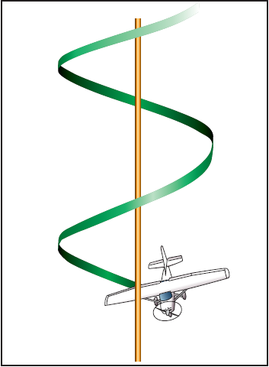

Spin Axis

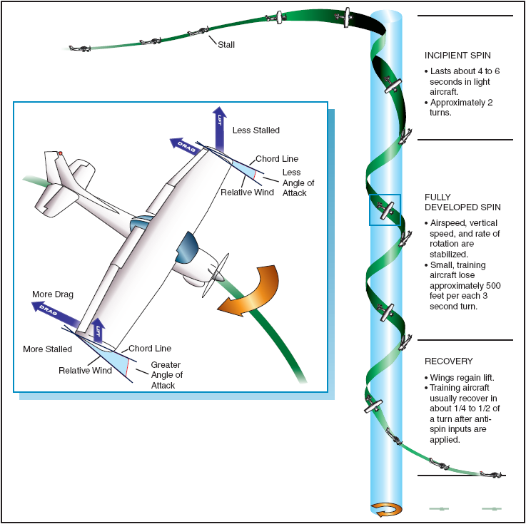

Spin stages